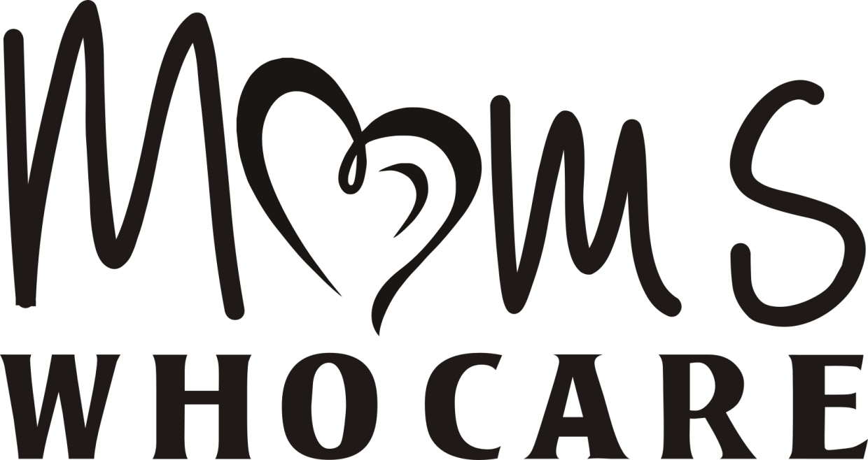
Helping students achieve success by providing essential needs
515 Pleasant Hill Road, East Peoria, IL 61611
309-635-1569
Momswhocare1@gmail.com
Wish List
Personal Hygiene: (full size if possible)
- Shampoo
- Conditioner
- Hair spray
- Hair styling products
- Toothpaste
- Toothbrushes
- Mouthwash without Alcohol
- Dental Floss
- Deodorant, boys and girls
- Body spray, boys and girls
- Bath gel
- Bath Scrubbies
- Lotion
- Tampons (Thin and maxi pads)
- Nail clippers
- Emery boards
- Acne pads and face wash
- Cotton balls
- Hairbrushes
- Combs
- Bobby pins
- Elastic hair ties
- Head bands
- Makeup, especially mascara
- Nail polish
- No Razors
Snacks:
- Easy mac-n-cheese
- Canned soups
- Non- refrigerated puddings
- Pop Tarts
- Breakfast and granola bars
- Individual fruit snacks
- Bottles of water
- Juice boxes
- Bumble bee tuna or chicken salad with crackers (Big lots!).

Wish List

School supplies: Page 2
- Spiral notebooks
- Mechanical pencils
- Pink erasers
- Index cards
- Colored pencils
- 3- Ring binders (1 inch or bigger)
- Highlighters
- Folders
- Sturdy string bags
Clothing:
- Gently used or new trendy clothing that teens will wear
- Girls- bras
  - Undies- bikini, hipster or boy shorts - no briefs please
  - Low cut socks in fun colors and patterns
- Boys- boxers- no briefs please
  - Low cut black socks
Services:
- Buy A Hair Cut
- School Dance Up Do’s
- School Dance Make-up
- Graduation Attire – Boys and Girls
  - Dresses
  - 8th Grade
  - Shoes
  - Dress pants and Dress Shirts
Misc:
- We love hoodies, yoga pants, cute purses, wallets, and belts
- Cash Donations, Checks made payable to Moms Who Care
  - (501c3, non- profit)
  - Cash donations are used students only
- Tax Receipts available for in-kind and cash/check donations

